Genetic Algorithms
Section #10
Particle Swarm Optimization (PSO)

Optimisation aims to find the best solution from a set of feasible options under given constraints. In many machine learning and engineering problems, the search space is complex, non-linear and multimodal, where traditional gradient-based methods may be ineffective. This makes population-based optimization techniques more suitable.
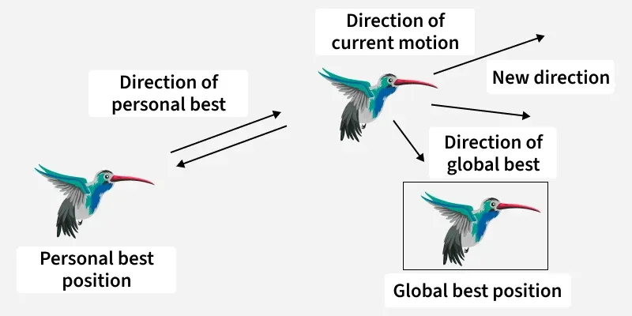
Particle Swarm Optimization (PSO) is a stochastic population based optimization technique inspired by swarm intelligence in nature. It is designed to solve complex optimization problems where the search space is large, non-linear or unknown, where traditional deterministic methods are ineffective.
- Each particle represents a potential solution and moves through the search space
- Movement is guided by both individual experience and collective swarm knowledge
- The algorithm iteratively improves solutions using a fitness function
- Simple to implement with fast convergence and few control parameters

How Particle Swarm Optimization (PSO) Works
Particle Swarm Optimization (PSO) is an iterative, population based optimization algorithm. It works by moving a group of particles (candidate solutions) through the search space using simple mathematical rules based on personal and collective experience.
Each particle in PSO has
- Position (x): current solution
- Velocity (v): direction and speed of movement
- Fitness value: quality of the solution
Each particle stores:
- pBest: best position found by itself
- gBest: best position found by the entire swarm
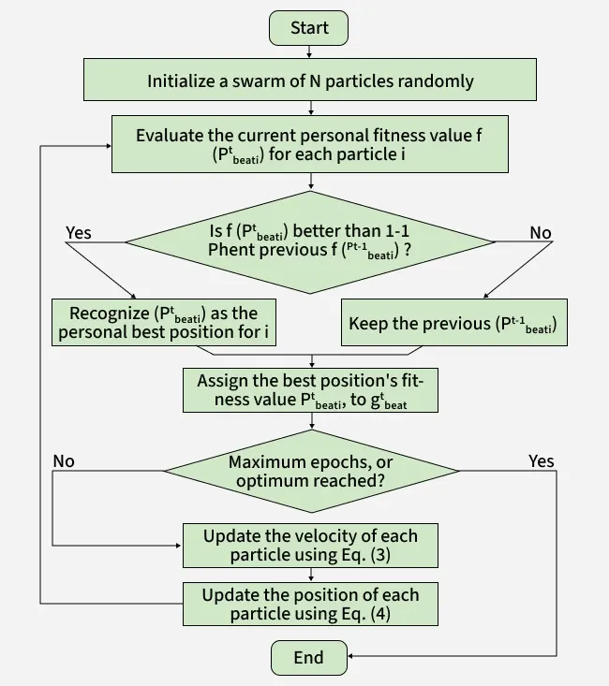

Step 1: Initialization
- Randomly initialize N particles within the search space $\left[minx , maxx\right]$
- Assign a random velocity to each particle
- Evaluate the fitness value of each particle
pBest = current position
gBest = best pBest among all particles
Step 2: Velocity Update
At each iteration the velocity of a particle is updated using:

where
- $w$: inertia weight (controls exploration)
- $c_{1}$: cognitive coefficient (self-learning)
- $c_{2}$: social coefficient (swarm learning)
- $r_{1},r_{2}$: random values in [0,1]

Step 3: Position Update
After updating velocity the position is updated as:
If the new position goes outside [minx,maxx] clip it to the boundary.
Step 4: Update Best Positions
- If current fitness is better than pBest, update pBest
- If current fitness is better than gBest, update gBest
Step 5: Convergence
- Repeat Steps 2–4 for a fixed number of iterations or until convergence
- The swarm gradually moves toward the optimal solution
Step By Step Implementation
Here in this code we implements Particle Swarm Optimization (PSO) to find the global minimum of the Ackley function by iteratively updating a swarm of particles based on their personal best and the global best positions.
It simulates collective behavior to efficiently search the solution space and converge to an optimal solution.
Step 1: Import Required Libraries
- Import numpy for numerical computations and vector operations
- Import math for mathematical constants and functions
- Import matplotlib.pyplot for possible visualization

import numpy as np
import math
import matplotlib.pyplot as plt

Step 2: Define the Cost (Objective) Function
- The Ackley function is a common benchmark function for optimization algorithms
- It is multimodal, non-convex and difficult for gradient-based methods
- PSO aims to minimize this function

def cost_function(x):
a = 20
b = 0.2
c = 2 * math.pi
d = len(x)

term1 = -a * np.exp(-b * np.sqrt(np.sum(x**2) / d))
term2 = -np.exp(np.sum(np.cos(c * x)) / d)

return term1 + term2 + a + math.e

Step 3: Define PSO Hyperparameters
- DIMENSIONS: specifies the search space dimensionality
- POPULATION: represents the number of particles
- MAX_ITER: controls the number of optimization iterations
- MIN_BOUND and MAX_BOUND: define the search space limits
- w, c1 and c2: are inertia, cognitive and social coefficients

DIMENSIONS = 2
POPULATION = 30
MAX_ITER = 100

MIN_BOUND = -5
MAX_BOUND = 5

w = 0.7
c1 = 1.5
c2 = 1.5
V_MAX = 0.5

Step 4: Define the Particle Class
- Each particle represents a candidate solution
- Particles have position, velocity and personal best
- Fitness is calculated using the cost function
- Personal best is updated whenever a better solution is found

class Particle:
def __init__(self):
self.position = np.random.uniform(MIN_BOUND, MAX_BOUND, DIMENSIONS)
self.velocity = np.random.uniform(-V_MAX, V_MAX, DIMENSIONS)
self.best_position = self.position.copy()
self.best_fitness = cost_function(self.position)
self.fitness = self.best_fitness
Step 5: Initialize the Swarm and Global Best
- A swarm of particles is created
- The global best solution is selected from all personal bests
- This global best guides the swarm during optimization

def particle_swarm_optimization():
swarm = [Particle() for _ in range(POPULATION)]

gbest_position = swarm[0].best_position.copy()
gbest_fitness = swarm[0].best_fitness

for particle in swarm:
if particle.best_fitness < gbest_fitness:
gbest_fitness = particle.best_fitness
gbest_position = particle.best_position.copy()

Step 6: Update Velocity and Position of Particles
- Velocity update includes inertia, cognitive and social components
- Random factors introduce stochastic behavior
- Velocity and position are clipped to avoid divergence
- This step enables exploration and exploitation

for iteration in range(MAX_ITER):
for particle in swarm:
r1 = np.random.rand(DIMENSIONS)
r2 = np.random.rand(DIMENSIONS)

particle.velocity = (
w * particle.velocity
+ c1 * r1 * (particle.best_position - particle.position)
+ c2 * r2 * (gbest_position - particle.position)
)

particle.velocity = np.clip(particle.velocity, -V_MAX, V_MAX)
particle.position = particle.position + particle.velocity
particle.position = np.clip(particle.position, MIN_BOUND, MAX_BOUND)

Step 7: Update Personal Best and Global Best
- Fitness is recalculated after position update
- Personal best is updated if a better fitness is achieved
- Global best is updated if any particle outperforms the current best

particle.fitness = cost_function(particle.position)

if particle.fitness < particle.best_fitness:
particle.best_fitness = particle.fitness
particle.best_position = particle.position.copy()

if particle.fitness < gbest_fitness:
gbest_fitness = particle.fitness
gbest_position = particle.position.copy()
print(f"Iteration {iteration+1}/{MAX_ITER}, Best Fitness = {gbest_fitness:.6f}")
return gbest_position, gbest_fitness

Step 8: Execute the PSO Algorithm
- The PSO function is executed from the main block
- Final optimal position and fitness value are printed
- The result approximates the global minimum of the Ackley function

if __name__ == "__main__":
best_position, best_fitness = particle_swarm_optimization()

print("\nOptimal Solution Found:")
print("Best Position:", best_position)
print("Best Fitness:", best_fitness)

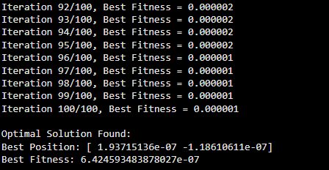
Difference between Particle Swarm Optimization (PSO) and Genetic Algorithm (GA)
Here we compare Particle Swarm Optimization (PSO) and Genetic Algorithm(GA):

Parameter | PSO | Genetic Algorithm (GA)
Inspiration | Based on social behavior of birds or fish | Based on natural evolution and genetics
Search Strategy | Particles move continuously through the search space | Uses randomized population evolution
Population Update | No creation or deletion particles only change position | New individuals are created using crossover and mutation
Operators Used | Velocity and position updates | Selection, crossover and mutation
Variable Handling | Best suited for continuous optimization | Handles both continuous and discrete variables
Complexity and Speed | Simple structure with faster convergence | More complex and generally slower
Application
1. Health Care Applications
- Intelligent Diagnosis: Optimizes models for faster and accurate disease detection.
- Medical Robots: Guides robots for precise surgical or therapeutic tasks.
2. Environmental Applications
- Wild Vegetation Monitoring: Tracks forest and vegetation growth efficiently.
- Agriculture Monitoring: Optimizes crop management and environmental monitoring.
- Flood Control and Routing: Predicts floods and finds optimal evacuation or routing paths.
3. Industrial Applications
- WSN Deployment: Optimizes sensor placement in Wireless Sensor Networks.
- Product Defection Prediction: Predicts defects to improve product quality.
- Microgrid Design and Operation: Optimizes design and operation for stability.
4 Smart City Applications
- Smart City Planning: Optimizes urban energy, traffic and resources.
- Smart Home Automation: Efficiently controls and schedules home appliances.
- Appliance Scheduling: Reduces energy consumption via optimal use.
Advantages
- Simple to implement with fewer control parameters.
- Fast convergence compared to many traditional algorithms.
- Does not require gradient information.
- Effective for non-linear and multimodal problems.
- Easily used with other optimization techniques.
Limitations
- May converge early to local optima.
- Weak local search capability in later iterations.
- Performance depends on proper parameter tuning.
- Computational cost increases with swarm size.
- Less effective for discrete optimization problems.

